Unstructured data analysis, processing and interpretation- a heuristic approach, based on ontologies

ANCA MARIA MITREA
IT&C Security Master
Academy of Economic Studies, Bucharest
6 Piata Romana, 1st district, Bucharest, 010374
Romania
E-mails: mitreaancamaria@gmail.com, mtr.anca@yahoo.com

Abstract: This is a sample of the format of your full paper. Use Word for Windows (Microsoft) (or equivalent Word Processor with exactly the same "printing results") using A4 mirroring page by tuning -3.56 cm for inside and -3.13 cm for outside in the Microsoft Word package. Use for the top use -2.54 cm, for the bottom -7.35cm and for the gutter 0cm. Please use single space for paragraphs. Use double-column format after the Key-Words. Please use Arial font with 10pt size for text and for abstract use Arial font with 9pt size. For the words Abstract, Key-Words and References use Italics.

Key-Words: ontology, heuristic, unstructured data, key-word, semantic, algorithm, context

1 Introduction

It is well known that lately we have witnessed an explosion in marketing content and the rapid evolution of marketing techniques and research into social networking. This has been influenced by technological and algorithmic evolution and has changed the way we produce and consume content and data.
The information is provided in various formats, giving the form of unstructured, semi-structured and structured data. Unstructured data, often identified by unstructured information, refers to information that, on the one hand, does not have a predefined data model or, on the other hand, is not organized in a predefined manner (Unstructured data, 2015). It cannot be easily classified or organized in an elegant manner and can be of different types, from photos and graphics, video content, WEB pages, PDF files, PowerPoint presentations, emails or blog articles. Broadly speaking, unstructured information is a sequence of text, but it may also contain other types of data such as numbers or dates. This leads to irregularities and ambiguities that make it difficult to comprehend using traditional programs to take into account the data stored in the database fields or annotated (semantically labeled) in the documents. In 1998, Merrill Lynch formulated a rule stating that about 80-90% of business information with utility potential could come in a unstructured form (Structure, Models and Meaning: Is "unstructured" data merely unmodeled?, 2005). The formulation of this rule is not based on primary or quantitative research, but is accepted in a very large proportion (Malone, 2007). However, techniques such as Data Mining, Natural Language Processing (NLP) or Text Analysis offer different methods to find data models, or otherwise formulated, to interpret this information. Common text structuring techniques usually involve manual tagging with metadata or natural language labeling to get a text-based structure. Because unstructured data often occurs in electronic documents, using a content or document management system that can classify entire documents is often preferred over data transfer and document manipulation, and search engines have become popular tools for indexing and searching through such data, especially text search.
Boolean key searching within text files or documents was always an extremely generic process and has been used at a certain level by most of the automatically analysis methods and in various areas of background applications. In many domains, the assisted key searching algorithms are not available, beyond simple approaches. This situation becomes problematical because selecting all the key words that identify a specific domain or concept is knows to be an almost impossible process to be done by a human being (Hayes P. J., 1990). Indeed, many sophisticated methods for automatic text analysis have been designed to get around simplistic and demonstrable appropriate matching of keywords and counting methods, but have proven to require their demonstration of utility and validity from the start. In some areas of applicability, there are external sets of data for minning key words beyond the text, like some search engine and interrogation platforms (example: Google AdWords KeyWord Tool, Overture Keyword Selection Tool), databases that contain meta tags or WEB journals (Yifang, 2008) and a wide literature of methods of expansion of the key words or suggestions has been born, in order to be exploited.
Without the help of a computer, human beings often think efficient enough to to select the key words from a specific text and this fact has been demonstrated if we refer at the way we use the Google search engine. However, as the specialty literature and the studies demonstrated, in order to perform a more complex task of choosing a key word set in order to select an objective set of words from a set of given words, even the more experienced users are not always very reliable. In other words, by giving two users that are familiar with the same subject or the same area of knowledge and with the same task, they will usually select sets of words that will intersect very little and each of them will be recognized as being, in fact, useful. And, of course, without showing the reliability, the validity of the sets is not even defined (Grimmer, 2011).
In fact, obtaining this pattern is an expected outcome, given a set of highly documented and counterintuitive conclusions from a psychological investigation of "inhibition processes." Many psychological experiments have been devoted to trying to obtain a revocation of a set of words belonging to a domain or topic. In this situation, the disclosure of a word facilitates the memory of others, but indicating a direction by revealing several words in a set strongly inhibits remembrance of the rest of the set words. Regarding the subject of this paper, what seems to happen is that a person can often provide a small number of keywords related to a particular aspect or event (Roedinger, 1982). However, the clues provided by the first words degrade the person's ability to retrieve similar keywords from memory as well as those related to different aspects of the same subject.
The difficulty of manually recalling keywords is exacerbated by the fact that it is possible for a human user not to be fully aware of many of the keywords that could be used to classify the document search in a target set. It is also unlikely that users will be able to find many keywords within a reasonable time by directly examining or reading any subset of a large number of documents in the search or reference set (King, 2003).
The algorithms that meet the previously identified requirements suggest a number of new areas of application. Some of these areas of application overlap to a certain extent, and I will present a short separate summary in order to highlight the different areas from which the use of these algorithms might occur. Conversational political drift scientists, lobby groups, newspapers, interested citizens, and other people often follow social networking talks on a particular topic, but are at risk of losing the main thread of the discussion and the most of it, when changes occur in the way others refer to that subject. Therefore, selecting an incomplete set of keywords may result in severe gradient selection misalignments, as they may be correlated with the studied opinions. There is a need for a method of extracting these sets of documents and defining keywords directly from the text as it is written, rather than waiting for most people to realize these words and look for them, so that information can be collected from WEB blogs and other search data (King, Method and Apparatus for Selecting Clusterings to Classify a Predetermined Data Set, 2013).

2 Problem Formulation

The text is the predominant environment for the exchange of information between experts (Hearst, 1999) and between the ordinary populations, being a handy way of communicating. The volume of literature and written information grows at such a rate that it is difficult to locate, take over and efficiently handle relevant information without the use of an algorithm or exploitation application. In order to share the large amount of information in an effective way, a link must be made between the evidences identified in the text and the ontologies, as the main officially represented knowledge repositories. Ontologies are conceptual models that aim a consistent and unambiguous support for knowledge sharing and provide a framework for the integration of knowledge (Stevens, 2000). Ontology connects conceptual labels to their interpretations, or in other words, the specifications of their meanings including definitions of concepts and relationships to other concepts (Uschold, 1998). In addition to relationships such as "is a" or "has a" generally present in almost any field, ontologies shape domain-specific relationships, such as "has location," "associated with," specific to particular domains. Therefore, ontologies reflect the structure of the field and constrain the potential interpretations of its specific terms. As such, ontologies can be used as a support for automatic semantic interpretation of textual information and thus provide a basis for sophisticated textual exploitation.

2.1 Methodology
Many of the ontologies expose different degrees of common coverage, exhaustiveness and specificity, as well as very different points of view related to conceptual space. Therefore, text-based applications that rely on several ontologies must also include mapping methods between such ontologies (Koehler, 2005). These methods, along with domain-specific applications that rely on ontologies, would take advantage of the standard language of ontology. However, even when using a single standardized ontology, it is not always simple to correlate textual information with ontology that benefits from the inherent properties of language. At least two major obstacles can be identified in this process: the inconsistency and inaccuracy of the practice of naming concepts specific to the domain (terminology) (Ananiadou, 2004) and the use of incomplete ontologies as a result of the rapid expansion of knowledge. However, a complete body of knowledge is currently stored in the field-specific ontologies, which can be used in many ways by textual exploration and interpretation. Moreover, the results provided by these applications can be maintained and used in order to facilitate the update of the ontology of the specified domain.
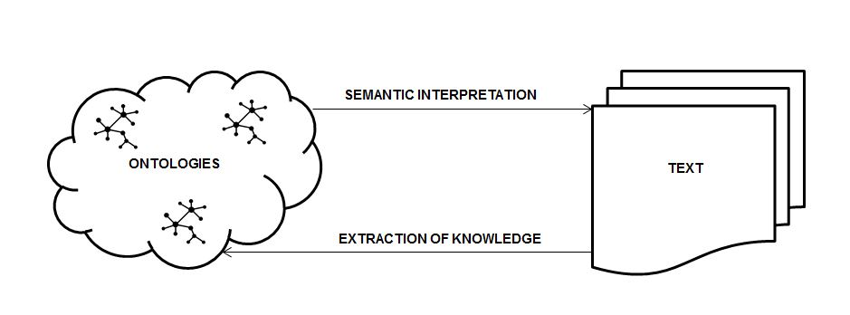
Figure 1- The links between text and ontology

According to Figure 1- The links between text and ontology, we can identify that ontologies provide descriptions that can be read automatically, along with their relationships. The correlation of domain-specific terms by the textual representation of these concepts in their description in ontologies provides an information platform for the interpretation of textual information. An explicit semantic layer supported by the use of ontologies allows the text to be exploited to obtain interpretive information specific to the chosen domain, unlike the simple correlations discovered by exploiting textual data using statistical information on the links between the target classes of terms in the area of ​​interest. Knowledge extracted from text using advanced textual exploitation techniques can then be processed and used to update ontologies that are currently lagging behind in attempts to keep up with the new knowledge emerged with the rapid expansion of most areas of research.
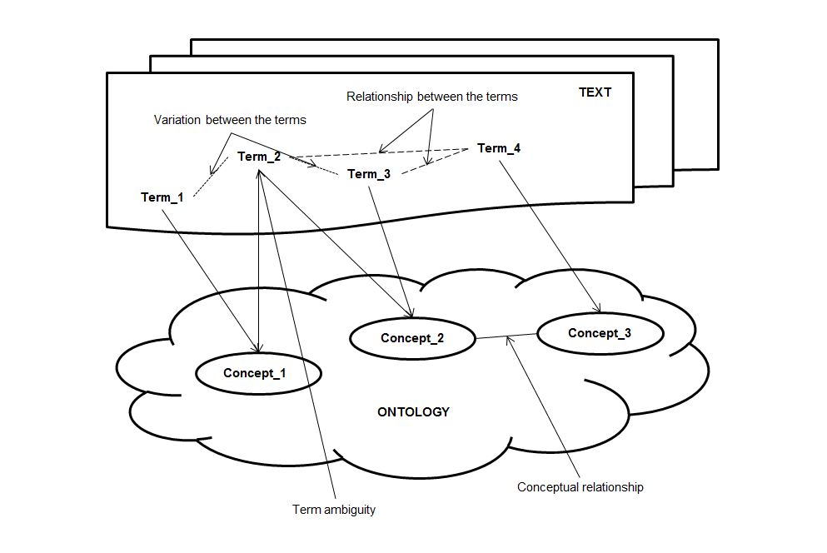
Figure 2- The links between text and ontology schema

The main link between text and ontology is a terminology that aims at mapping concepts with terms (Figure 2- The links between text and ontology schema). A term is defined as a textual realization of a specialized concept (example: phishing, malware, defense). The introduction of a new term implies the creation of a new concept, indicating a certain area of ​​knowledge of information space (Sager, 1990) (Meyer, 1997). This process involves correlating a term to a concept in ontology. This mapping is crucial for semantic interpretation in textual exploitation applications and is a process far from being trivial. The main problems arise from the fact that there is often no one-to-one correspondence between concepts and terms. In practice, text-based applications face problems related to the variation and ambiguity of terms, which make the information available in the text and the ontologies difficult to integrate. The variation of terms comes from the ability of a natural language to express a single concept through a number of modalities, called synonyms.
The ambiguity of terms occurs when the same term is used to refer to several concepts. Ambiguity is an inherent feature of natural language. By object, words have more entries in the dictionary and the meaning of a word can be changed by the context in which it is used. The sublimes, being languages restricted to specialized fields (Harris, 2002), provide a context that generally reduces the level of ambiguity. However, most areas include a number of subdomains, being an additional cause of increasing the level of ambiguity of terminology (Spasic, 2005).

3 Problem Solution

A fully automatic analysis program can be regarded as a heuristic problem rather than a purely algorithmic one. A heuristic technique sometimes referred to simply as heuristic is any approach to problem solving, learning or discovery that uses a practical method that is not guaranteed to be optimal or perfect, but sufficient for immediate purposes. If finding an optimal solution is impossible or impracticable, heuristic methods can be used to speed up the process of finding a satisfactory solution. Heuristics can be mental shortcuts that ease the cognitive task of making a decision (Wikipedia- The Free Encyclopedia, 2015). In particular, heuristics are strategies that use information that is easily accessible and, at the same time, vaguely applicable to control problem solving by human beings and machines (Pearl, 1983). A.L. Samuel has recently established some of the characteristics of an intellectual activity (Samuel, 1959), in which heuristic procedures and learning processes can play a major role: the activity must not be deterministic in the practical sense; There must be a clear objective and at least one criterion of an intermediate objective that is based on achieving the ultimate goal and whose sign should be known; The rules of the activity should be defined and known; There is a need for a knowledge base of the activity on the basis of which learning progress is tested; The activity must be familiar to a substantial mass of people, so that program behavior can be comprehensible to them.
The criteria outlined above seem to be applicable also to automated textual analysis. Therefore, analysis can be paraphrased as follows: textual processing and interpretation is not deterministic in the practical sense. There is no algorithm to guarantee success in the analysis and the full exploitation of each combinatorial criterion could involve an astronomical number of steps. There is also a clear objective - a detailed distributional declaration and intermediate objectives can be formulated, which are based on achieving the ultimate goal. These could be broader distribution declarations, from which finite, more specific and refined classifications can be derived. Activity rules are defined and can be formulated. Of course, this presupposes the acceptance of a basic hypothesis, the possibility of discovering linguistic procedures. The procedures that have proved to be most useful in linguistic analysis are those of substitution and fixation (Garvin, 1961). They can be made computationally and can be introduced into the heuristic linguistic analysis, after the completion of a set of necessary preliminary steps. Of course, there is a foundation for knowing the activity against which machine results are tested: linguistic analysis is, or can become a set field, and machine results can be compared to those of human beings. Although linguistic analysis is not familiar to most of the population, its results can be compared to the intuitive behavior of the entire discourse community and the behavior of the program can be explained in terms of this intuitive behavior.

4 Conclusion

Starting from the prerequisites of exponential growth of the information volume in electronic format, as well as the need to find a quick and efficient way of analyzing, processing and textual interpretation, there is a context in which new tools can be developed to address this need. Also, on the basis of the same basic idea, the existence of a very large volume of information with a content that is susceptible to generating benefits, regardless of their nature, it is necessary to identify a way of giving meaning or semantics to them, in a way that is automatic. Therefore, due to the existence of a large amount of unstructured information, as well as the use of resource-structuring methods, the implementation of an algorithm that facilitates textual analysis is an appropriate solution.

References:

